**qemu-img for Windows**

**QEMU disk image utility** for Windows. It is used for converting, creating, and consistency checking of various virtual disk formats. It is compatible with Hyper-V, KVM, VMware, VirtualBox, and Xen virtualization solutions. This build has been optimized for Windows Server (x64).

### Usage examples

**Convert a QCOW2, RAW, VMDK or VDI image to VHDX**

qemu-img.exe convert source.img -O vhdx -o subformat=dynamic dest.vhdx

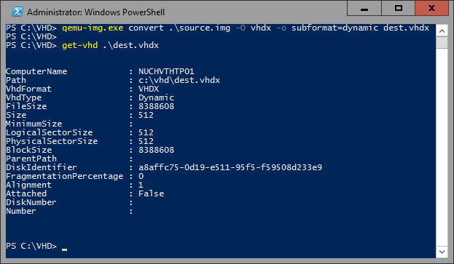

**Convert a QCOW2, RAW, VMDK or VDI image to VHD**

qemu-img.exe convert source.img -O vpc -o subformat=dynamic dest.vhd

Subformat can be either “dynamic” or “fixed” for VHD (vpc) or VHDX.

Note: use the fixed VHD subformat for [Azure](https://docs.microsoft.com/en-us/azure/virtual-machines/linux/create-upload-generic), the conversion will automatically take care of the required 1MB virtual size alignment.

**Check a virtual disk for consistency**

qemu-img.exe check source.qcow2

**Get info about a virtual disk**

qemu-img.exe info image.qcow2

Run **qemu-img.exe -h** or see the [manual page](https://qemu.weilnetz.de/doc/) for a complete list of all supported options.

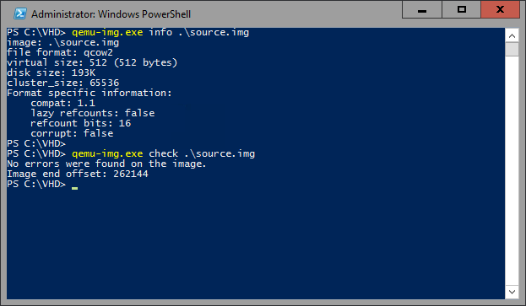

### Supported formats

|  |  |
| --- | --- |
| **Image format** | **Argument for -f and -O options** |
| VMDK (VMware) | vmdk |
| QCOW2 (KVM, Xen) | qcow2 |
| VHD (Hyper-V) | vpc |
| VHDX (Hyper-V) | vhdx |
| RAW | raw |
| VDI (VirtualBox) | vdi |

### Download binaries

[qemu-img 2.3.0 for Windows x64](https://cloudbase.it/downloads/qemu-img-win-x64-2_3_0.zip)

### Links

**Source code:**<https://github.com/cloudbase/qemu>  
**QEMU’s project main page:**[http://www.qemu.org](http://www.qemu.org/)  
**Alternative QEMU binaries:**<http://qemu.weilnetz.de/>  
**Documentation:**<https://qemu.weilnetz.de/doc/>